Diary No. 3

Week 3: On-Line

Topic: Skill and Chance (Nought and Crosses)

Date: 17/10/2020

Game Title: Chances and Crosses

Team Members: Jamie Smith, Callum Morgan-Pook and Ali Noorani (myself)

External Play Testing Team Members: James Wilson and Muhammed Zulfiqar

1. **The Game Premise:**

The basis of the task was to make the game of noughts and crosses better than it already was. Adding something that would improve the game further and make it more fun and interesting to play with added skills such as luck and chance.

The team started off with thinking about different ideas of what they could do to make it better. The first thought that came into everybody’s mind was that the game was already good. The question was, how could they make it better?

They came up the idea of adding something between each player turn to make the game more interesting… but what? A team member suggested to make the board bigger, increase the size of the board to a 4x4, to make the players use their brains a little more, as the regular 3x3 grid was so common that all the viable strategies had already been discovered. With this in mind, another member suggested the idea of having a 4 in a row to win the game. As this made the game more interesting to play, in our minds, because players would need to use and come up with different/ new strategies to win, it would make them use their mind more than a regular game. The idea of increasing the board size was nice, but game was more or less the same as a regular game; The team needed to think of something new to add to the game.

A member then suggested an idea to add the rock, paper, and scissors game into the mix. The addition of the game would serve the purpose of deciding which player would go first and if the player would get their move/ turn or not.

The team internally play tested the game and found that the game mechanic of rock paper scissors, for deciding whether the player would get their turn or not would occur much more frequently than the player could take in. The game needed it to be spaced out and have a little bit more down time. Hence, the team decided to change it so that each player would get an equal amount of turns, however, the player who goes first is decided by the game of rock, paper, and scissors.

A team member came up with the idea of turning the game into 3D. Inspired by the game of 3D chess. The purpose of the idea was the same as the purpose of making the game grid into a 4x4, so the team decided to remove the 4x4 grid idea and make the game 3D and use a regular 3x3 grid.

With the game idea ready, the team went on to decide what materials the game would need, its rules and mechanics, how the game would be played, and finally externally play test it.

1. **The Material List:**

As the game was now being played as a 3D game, it would take a long time to draw the grid out for the game. To remove that unnecessary time usage, the team decided to have the game become a board game, with all the pieces in a box.

Here are all the pieces needed:

* The main board where the game was going to be played. Figure 1A.
* The ‘X’ and ‘O’ pieces used to play and win the game. (18 each) Figure 1B.
* 1 Hand from each player

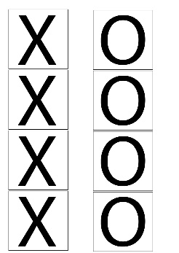

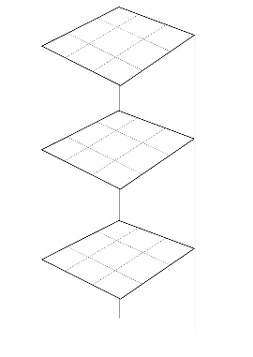

B

A

Figure 1(A): The Game Board. (B) The Pieces of Noughts and Crosses

1. **Rules and Mechanics: -**

**Rules:**

* At the start of the game, the players play a game of rock, paper, and scissors to decide who goes first. The player who wins goes first.
* Once the player who won the game of rock, paper, scissors has made their turn on the main board, the second player makes their move on the board.
* The game of rock, paper, scissors is then repeated to decide who goes next. The winner goes next and the loser follows up after the winner.
* This is then repeated until one player gets 3 in a row and wins the game.

**Mechanics:**

* To win a game of 3D Noughts and Crosses, the player needs to get 3 in a row in a pattern where a straight line can be formed across the noughts or the crosses.
* The straight line can be connected horizontally, vertically, and diagonally within the board.

1. **How the Game is played (With Pictures):**

* The players start off with a game of rock paper scissors. The winner goes first.

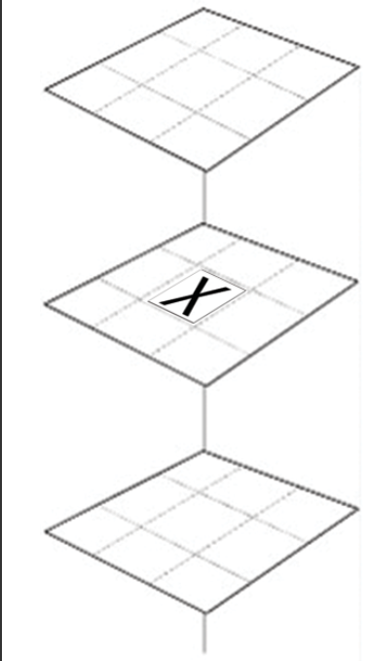

* The second player goes next.

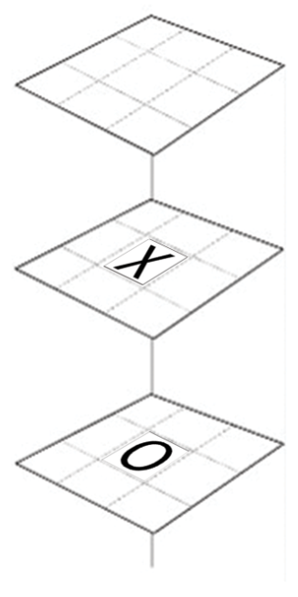

* 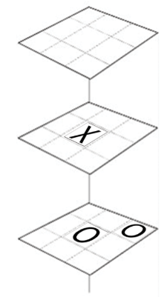The game of rock paper scissors is repeated, and the winner goes next.

The second player won the game of rock paper scissors and was able to get ahead of the game

* Now the first player gets to make their move.

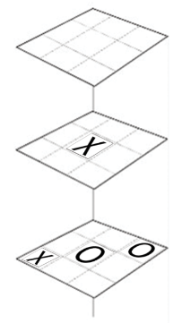The first player was forced to make that move as they could not afford the chance of losing the next game of rock paper scissors and hence losing the entire game.

* The rock paper scissors game is played again. This time the first player won.

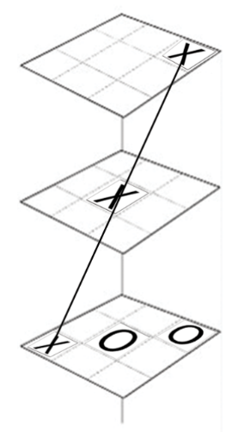

The first player won and made their move to win the game as they made a 3 in a row diagonally in a straight line.

1. **External Play Testing Results and Findings:**

Here are a few results from the team’s external play testing:

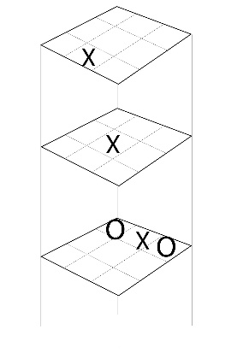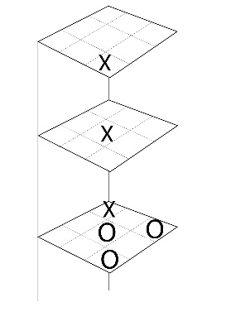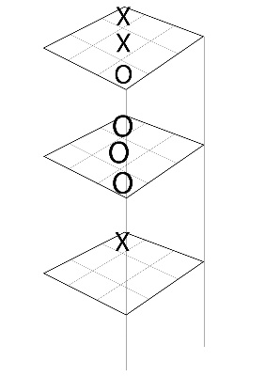

C

B

A

Figure 2(A): External Testing Result 1. (B): External Testing Result 2. (C): External Testing Result 3.

The team’s external play testing found that although the game was “fun to play”, it took a lot less time than expected. All 3 games finished very quickly. The team thought about how they could make it last longer, and the idea of making the grid bigger and having a 4 in a row came into mind again. However, this posed a problem in front of them. If the grid was 4x4, the main board itself would need to have 4 boards layered on top of each other, to make a 4 in a row vertically as well as horizontally.

The team, then started to look at positives of having the game run short. It allows different players who might be waiting in line, get a turn quicker, and it stops the game from running too long and making the game boring from the players perspective. Another positive of this game was that the more the players played this game, the better their skill got, as they were learning new strategies and techniques to block the other player and win the game.

1. **Experience of Working in Teams:**

The team overall, had great ideas in their mind to improve the game. Their team working skills were amazing. They were able to come up with a game idea within 5 minutes of the 20 minutes thinking time. They then developed the idea for a further 10 minutes while doing the internal play testing. For the 40 minutes, each team member was assigned different tasks.

One designed the board, while one made the power point presentation for the team to present at the end, while one thought about how the game would be played out, its rules and mechanics. Once the game pieces were made, the designing team member joined in thinking of the main game rules. They all then, finished their power point presentation and did external play testing with the other team while also testing out their game.

The external play testing was complete, and the comments were added into the power point presentation 5 minutes before the 40 minutes were done. They then allocated each slide to different members to talk about and finished just in time for the presentation to take place.

In order for the team to improve their performance and presentation, ‘I’ would recommend getting more play testers, in terms of more teams to play test with, and allowing more time to think of ideas to make the game even more fun and intense to play.

Sources: -

* The game board design was inspired from:

www.doodlemaths.com/3d-noughts-and-crosses-puzzle